# **Retrieval of Immunization Data via Bulk FHIR**

The purpose of this document is to assist public health professionals in understanding the capabilities of Bulk FHIR and to promote a unified method across the sector.

The Bulk FHIR data access method facilitates the sharing of data on populations of individuals and is a Priority Area for the Helios FHIR Accelerator for Public Health. This approach allows users of Electronic Health Records (EHR) systems and other electronic platforms to utilize the carefully curated data managed by public health programs. By implementing FHIR Bulk data, authorized users can efficiently retrieve data for defined groups through a standardized and reusable method. This process enables public health systems to generate and transmit essential information quickly while reducing the time and effort needed to respond to data requests in proprietary and custom formats.

This document focuses on providing authorized users access to immunization information maintained by jurisdictional immunization programs. Although the Helios FHIR Accelerator has concentrated on an immunization use case, the Bulk Data method and considerations discussed here are relevant to other data-sharing scenarios critical to public health activities.

**Retrieval of Immunization Data via Bulk FHIR 1**

Introduction 5

What is the purpose of this document? 6

What is the FHIR Bulk Data Approach? 6

Which Public Health Use Cases Could Utilize Bulk Data? 6

General Use Cases 6

Immunization-Specific Use Cases 7

Who is Involved? 8

What are the Steps in Accessing Bulk Data? 8

What are the Benefits of Bulk Data Access? 9

Policy Considerations 10

Data Sharing and Consent 10

Patient Identification 10

Data Privacy and Security 11

Confidentiality, Compliance and Legal Frameworks 11

Technical Infrastructure and Interoperability 11

Data Usage and Secondary Analysis 11

Governance and Oversight 12

Integration and Harmonization of Data Sets 12

Technical Concepts 12

Bulk Data Access FHIR IG Overview 12

Operation Types 13

FHIR Group Resource 13

Parameters 13

Security Expectations 14

Technology Implementation 15

FHIR Implementation 15

Staging of Data 16

General Considerations 17

Group Types 17

Persistent Groups (enumerated) 18

Transient Groups (enumerated) 18

Characteristic Groups 19

Maintaining Cohorts 19

Considerations for maintaining a cohort 19

Data Payload 20

Trading Partner Expectations 21

Foundational Technical Requirements 21

Foundational Operational Requirements 22

Mechanisms for Patient Identification and Group Creation 23

V2-Mediated Matching (Automatic Group Creation) 23

Description 23

Assumptions 24

Group Types Supported 25

Persistent Groups (enumerated) 25

Benefits 25

Limitations 25

Technical Requirements 25

IIS HIT Vendor 25

Authorized User HIT Vendor 26

Operational Requirements 26

Immunization Program 26

Authorized User 26

Implementation Considerations 26

V2-Mediated Matching (Dynamic Group Creation) 26

Description 26

Assumptions 27

Group Types Supported 28

Transient Groups (enumerated) 28

Persistent Groups (enumerated) 28

Benefits 28

Limitations 28

Technical Requirements 29

IIS HIT Vendor 29

Authorized User HIT Vendor 29

Operational Requirements 29

Immunization Program 29

Authorized User 29

Implementation Considerations 29

FHIR-Mediated Matching (Individual) 30

Description 30

Assumptions 30

Group Types Supported 31

Transient Groups (enumerated) 31

Persistent Groups (enumerated) 31

Benefits 31

Limitations 32

Technical Requirements 32

IIS HIT Vendor 32

Authorized User HIT Vendor 32

Operational Requirements 32

Immunization Program 32

Authorized User 32

Implementation Considerations 32

FHIR-Mediated Matching (Bulk) 32

Description 33

Assumptions 33

Group Types Supported 34

Transient Groups (enumerated) 34

Persistent Groups (enumerated) 34

Benefits 34

Limitations 34

Technical Requirements 35

IIS HIT Vendor 35

Authorized User HIT Vendor 35

Operational Requirements 35

Immunization Program 35

Authorized User 35

Implementation Considerations 35

Flat File Mediated Matching 35

Description 35

Assumptions 37

Group Types Supported 37

Transient Groups (enumerated) 37

Persistent Groups (enumerated) 38

Benefits 38

Limitations 38

Technical Requirements 38

IIS HIT Vendor 38

Authorized User HIT Vendor 38

Operational Requirements 39

Immunization Program 39

Authorized User 39

Implementation Considerations 39

Reuse of Existing Groupings 39

Description 39

Assumptions 40

Group Types Supported 40

Persistent Groups (enumerated) 40

Benefits 40

Limitations 40

Technical Requirements 41

IIS HIT Vendor 41

Authorized User HIT Vendor 41

Operational Requirements 41

Immunization Program 41

Authorized User 41

Implementation Considerations 41

Online Interface 41

Description 41

Assumptions 42

Group Types Supported 42

Transient Groups (enumerated) 42

Persistent Groups (enumerated) 42

Benefits 42

Limitations 43

Technical Requirements 43

IIS HIT Vendor 43

Authorized User HIT Vendor 43

Operational Requirements 43

Immunization Program 43

Authorized User 43

Implementation Considerations 43

Subscription to Patient with Bulk 43

Description 43

Assumptions 44

Group Types Supported 44

Transient Groups (enumerated) 44

Benefits 45

Limitations 45

Technical Requirements 45

IIS HIT Vendor 45

Authorized User HIT Vendor 45

Operational Requirements 45

Immunization Program 45

Authorized User 46

Implementation Considerations 46

Mechanism for Bulk Query 46

Summary 46

## **Introduction**

### **What is the purpose of this document?**

The purpose of this document is to help public health professionals understand the capabilities of Bulk FHIR, including its methodology and implications, and to foster a unified approach across the sector. This document covers the following topics:

* Policy considerations and implications for implementing Bulk Data Access using FHIR
* Technical concepts and options for developing a supporting FHIR infrastructure
* Expectations for trading partners
* Methods for identifying and grouping individuals
* Approaches for executing bulk queries

This document is produced by the [Helios FHIR Accelerator](https://confluence.hl7.org/display/PH/Helios+FHIR+Accelerator+for+Public+Health+Home) for Public Health [Bulk Data Priority Area](https://confluence.hl7.org/display/PH/Bulk+Data). This group of volunteers examined potential uses of Bulk Data exchange to understand the approaches data exchange partners may adopt and to identify considerations for implementers. While the Bulk Data Priority Area has focused on sharing immunization-related data, the information in this document is also applicable to other public health data-sharing scenarios. Additionally, although this document is developed for the US context, it may be relevant to other regions as well.

### **What is the FHIR Bulk Data Approach?**

The [FHIR Bulk Data](https://hl7.org/fhir/uv/bulkdata/) approach effectively exchanges large health data sets on populations rather than individuals. This approach is detailed in the FHIR Bulk Data Implementation Guide, developed by the SMART Health IT project at Boston Children’s Hospital's Computational Health Informatics Program. This approach may be applied to a wide variety of public health data sets and a number of different Authorized User types including healthcare providers, payors, and community groups such as schools or community-based program providers. Regardless of the nature of the individual actors involved, the application of the FHIR Bulk Data approach provides a consistent framework for data exchange to minimize the use of bespoke formats. This white paper builds off the FHIR Bulk Data Access Implementation Guide to describe the specific application of this generic approach to public health data sharing needs, using the exchange of immunization data held by jurisdictional programs as a pilot use case. A more detailed description of this approach is provided in the Technical Concepts section of this document.

### **Which Public Health Use Cases Could Utilize Bulk Data?**

#### **General Use Cases**

Many public health programs collect, collate, and curate valuable data sets as part of their mission. This information benefits not only public health but also organizations that interact with both small and large populations to provide healthcare, services, support, and other interventions. By offering authorized users improved access to these data sets, public health can enhance health outcomes and quality of life for community members.

Adopting FHIR-mediated bulk data exchange will promote expanded data sharing while minimizing the time and effort required from both authorized users and public health agencies. Various public health programs serve as data stewards, including healthcare providers, payers, service providers, and community programs. Use cases discussed within the Helios Bulk Data Priority Area include:

* **Vital Records Birth Certification Data**: Useful for public health programs monitoring newborns and providing support and services.
* **Vital Records Death Data**: Enables service providers, such as healthcare organizations and payers, to update records for individuals who have passed away, reducing costs associated with unnecessary resource allocations and alleviating the emotional toll on survivors due to inadvertent communications.
* **Data Exchange Between State and Local Public Health Programs**: Facilitates data sharing for geographically located populations.
* **Public Health Collated Data**: Supports care coordination with Medicaid agencies.

However, the primary use case explored within the Bulk Data Priority Area is the sharing of immunization-related data collected by jurisdictional immunization programs within an Immunization Information System (IIS). This use case is explored more thoroughly below.

#### **Immunization-Specific Use Cases**

The [Immunization Integration Program’s Bulk Query Toolkit](https://www.himss.org/resources/iip-bulk-query-toolkit) identifies several immunization-specific use cases that can benefit from FHIR bulk data exchange instead of individual queries:

* **Obtain Immunization Records**: Retrieve records for all patients with clinic appointments the following day.
* **Limit Reminder or Recall Communications**: Target communications to patients who are due or overdue for a vaccine dose.
* **Evaluate Clinical Care Quality**: Assess performance measures, such as the Healthcare Effectiveness Data and Information Set (HEDIS).
* **Support Public Health Agency Disease Case Investigations**: Utilize vaccination status, demographic data, and other qualifiers.
* **Evaluate Vaccination Status**: Assess large groups, such as coverage rates for health plans, schools, or emergency first responders.
* **Provide Proof of Vaccination**: Supply consumers with documentation for employment, travel, education, or large events.
* **Evaluate Vaccine Product Effectiveness**: Analyze data after Food and Drug Administration (FDA) and Advisory Committee on Immunization Practices (ACIP) approval.

### **Who is Involved?**

Four major partner roles are anticipated to be involved in the development and implementation of Bulk Data exchange for immunizations. Later sections of this document will outline the specific expectations and activities required for each role during the development and implementation process. These roles include:

* **Public Health Program**
* **Health Information Technology (HIT) Vendor** for public health systems
* **Authorized User Organization**
* **Authorized User HIT Vendor**

For this document, we will use a jurisdictional immunization program as an example, but similar approaches can apply to other public health programs. In this case, the HIT vendor for the immunization program will be the Immunization Information System (IIS) vendor.

Various organizations may qualify as Authorized Users for the immunization use case, including:

* **Healthcare Providers** (e.g., hospitals and clinics)
* **Payers**
* **Community-Based Organizations** (e.g., schools, community programs)
* **Other Public Health Programs**
  + Within the jurisdiction
  + From neighboring jurisdictions, such as local agencies

The needs and technical capabilities of different types of Authorized Users, even within the same category, can vary significantly. Therefore, not all approaches discussed in this document will be practical for every Authorized User. Implementers must fully understand the needs and capabilities of their trading partners and design an approach that can be effectively implemented on both sides of the exchange.

### **What are the Steps in Accessing Bulk Data?**

The application of the Bulk Data Access approach by an Authorized User involves several steps, including:

1. **Patient Identification**: Establishing patient identification between systems for a significant number of individuals.
2. **Cohort Creation and Maintenance**: Creating and maintaining cohorts of individuals.
3. **Use of a FHIR Operation for Bulk Data Exchange**: Utilizing a FHIR operation for bulk data exchange.

Note that only the last step is covered in the [FHIR Bulk Data Access Implementation Guide](https://hl7.org/fhir/uv/bulkdata/export.html), which assumes the existence of an agreed-upon cohort of individuals known by both systems. This guidance document will also explore approaches for identifying individuals at scale and for creating and maintaining cohorts to meet the necessary prerequisites for performing a bulk query.

### **What are the Benefits of Bulk Data Access?**

Using FHIR-based Bulk Data queries benefits both the data source and the Authorized Users requesting access. In the immunization sector, standard methods for querying and receiving data via HL7 V2 messaging exist, but these methods only support individual patient queries. The V2 standards optimize access on a one-by-one basis, which creates significant operational burdens on the Immunization Information System (IIS) when responding to multiple synchronous queries. This approach is often inefficient for the requesting Health Information Technology (HIT) system.

During the COVID-19 pandemic, immunization programs faced increased requests to pull data in bulk for large populations. Even when the IIS provided data at scale in a standard format, these requests typically relied on custom flat file mechanisms, requiring individual planning, coordination, and custom development, which created bottlenecks. Public health staff often lacked the capacity to respond to all data requests due to competing priorities. However, Bulk FHIR offers a standardized and replicable approach for large data access, similar to how HL7 V2 standardizes clinical access for individuals. This method enables consistent and secure access to data for Authorized Users, transforming immunization programs from isolated data silos into integrated data platforms.

Many Authorized Users, such as healthcare providers and payers, operate across different jurisdictions and request data from multiple sources. Historically, variations by jurisdiction have imposed significant burdens on Authorized Users and their HIT vendors, as each jurisdiction often required customized solutions for data exchange. By uniformly adopting FHIR-based Bulk Data exchange, the national landscape will become more harmonized for developers and implementers.

Additionally, FHIR provides a common data structure for representing immunization data. While extensive use of V2 messaging has promoted consistency across systems, FHIR offers a more accessible view of the immunization data model. By leveraging a Bulk Data query approach, immunization data will maintain a similar structure, regardless of its origin in different systems and architectures. Using FHIR for large-scale data exchange will facilitate the development of national resources and knowledge based on a shared understanding of data structure. Other initiatives, such as the [US Core FHIR Implementation Guide](https://www.hl7.org/fhir/us/core/index.html), [Quality Improvement (QI-Core)](https://hl7.org/fhir/us/qicore/), and the [International Patient Summary](https://hl7.org/fhir/uv/ips/), also utilize FHIR profiles for immunization data, and the use of FHIR for data sharing is expected to grow. The adoption of the Bulk FHIR approach described in this document aligns with these efforts.

The FHIR base standard includes three resources specifically related to immunization data:

* **Immunization Resource**: This resource describes the event of an individual receiving a vaccine, including both current and historical administrations. The complete set of Immunization resources linked to a specific individual constitutes their documented immunization history.
* **ImmunizationEvaluation Resource**: This resource documents the comparison of an immunization event against published guidelines to determine if the event is "valid" according to those guidelines.
* **ImmunizationRecommendation Resource**: Based on the individual's immunization history, evaluation against guidelines, and unique attributes, this resource provides a point-in-time set of recommendations (or forecasts) for the individual.

Depending on the specific use case being implemented, any or all of these resources may be included in the scope of a bulk data query as described in this document. Refer to the Data Payload section for more information.

Many of these benefits will extend beyond the immunization sector into other areas of public health data sharing.

## **Policy Considerations**

Most general policy considerations for immunization data exchange also apply to Bulk FHIR queries, such as a focus on interoperability standards, adherence to FHIR standards and profiles, and the use of standard terminology. However, using Bulk FHIR queries for immunization data introduces distinct policy considerations due to the scale, data aggregation, and potential for broader use cases. Key factors to consider include:

### Data Sharing and Consent

* **Informed Consent**: Bulk queries may include data from multiple individuals, necessitating clear policies on whether individual consent is required or if aggregate use is permitted under public health exceptions.
* **Scope of Data Access**: Bulk FHIR queries access data for multiple patients, which is broader than the data typically shared in individual immunization messages. Policies must clarify whether access is restricted to specific use cases, such as public health reporting or quality improvement.

### Patient Identification

* **Patient Matching**: The development of policies on how patients will be uniquely identified in bulk queries to ensure the correct matching of immunization records to the right individuals must be developed.
* **Query Approach**: The implications of using demographic query by parameter approaches versus unique identifiers must be considered along with the necessity of existing consent for identification.

### Data Privacy and Security

* **Volume of Data**: Bulk FHIR queries retrieve large datasets, increasing the risk of exposure in case of data breaches compared to individual immunization messages.
* **Access Control**: Organizations must ensure that only authorized entities access bulk data. This may involve role-based access control or additional permissions.
* **Need for De-identification**: For bulk queries, especially for research or population health, policies may require data de-identification or anonymization, unlike individual messaging, which typically uses identifiable data.

### Confidentiality, Compliance and Legal Frameworks

* **Compliance Standards**: Bulk queries must meet stringent compliance standards specific to the entity sending the query, ensuring adherence to regulations such as HIPAA (Health Insurance Portability and Accountability Act), FERPA (Family Educational Rights and Privacy Act) in the U.S., or GDPR (General Data Protection Regulation) in the EU, particularly regarding patient consent and data sharing.
* **Public Health Statutes and Reporting**: Policies may permit or restrict bulk data access for public health purposes, requiring clear boundaries between permissible and impermissible uses. Variations in laws can complicate compliance, especially when dealing with data across jurisdictions with differing data exchange regulations.
* **Data Retention**: Data retention policies may differ for regular immunization messaging and bulk queries.

### Technical Infrastructure and Interoperability

* **Performance Impacts**: Bulk queries may demand significant resources from FHIR servers. Policies might need to address rate limiting or scheduling to prevent disruption of other production services. Draft guidelines for handling large data sets effectively, including limits on the size and frequency of bulk queries to avoid system overload or performance issues. Consider policies for prioritization of queries based on urgency or public health needs.
* **Data Quality**: Bulk queries might highlight discrepancies or gaps in data (e.g., missing immunization records), or might inadvertently propagate problematic data, requiring processes for reconciling such issues.

### Data Usage and Secondary Analysis

* **Purpose Limitation**: Bulk FHIR data might be repurposed for analytics or research. Policies must ensure alignment with the original purpose of data collection and impose restrictions on secondary uses.
* **Equity in Data Use**: Bulk data could disproportionately benefit well-resourced organizations, policies should address equitable access to aggregated immunization data for public health benefit.

### Governance and Oversight

* **Auditing**: Policies for Bulk FHIR queries may require enhanced auditing to track who accessed data, when, and for what purpose (purpose in particular may be challenging to ascertain through bulk queries).
* **Partner Engagement**: Public trust is critical; governance frameworks might need to include a broad set of community stakeholders when creating policies for bulk data use.

### Integration and Harmonization of Data Sets

* **Consistent Interoperability Challenges**: Bulk FHIR queries could change the cadence of immunization exchange across partners within the health ecosystem (IIS, EHRs, HIEs, etc.), necessitating policies for harmonizing these datasets and avoiding data gaps or duplication.
* **Updates and Synchronization**: Policies should address how frequently bulk data can be queried and how updates to immunization records are synchronized.

In summary, while there are no absolute barriers to considering Bulk FHIR query use cases, this alternative method of data exchange requires comprehensive policies that account for increased data volume, broader access implications, and the potential for secondary uses beyond individual immunization messaging.

## **Technical Concepts**

### **Bulk Data Access FHIR IG Overview**

The [FHIR Bulk Data Access Implementation Guide](https://hl7.org/fhir/uv/bulkdata/) ( referred to as the Bulk Data IG) was developed and published by the [SMART Health IT project](https://smarthealthit.org/about-smart-2/) at Boston Children’s Hospital Computational Health Informatics Program. This standard addresses the need to efficiently access large volumes of information on groups of individuals. As of the time of publication of this document, the latest version of the implementation guide is version 2.0.0. All efforts undertaken by the Helios Bulk Data Priority Area have focused on this version of the standard.

According to the [Bulk Data Export Operation Request Flow](https://hl7.org/fhir/uv/bulkdata/export.html#bulk-data-export-operation-request-flow) section of the Bulk Data IG, a bulk data exchange typically involves two primary roles: the Bulk Data Server and the Bulk Data Client. For a detailed description of the system interactions involved, refer to the Request Flow section mentioned above. In this document, we will refer to this sequence of interactions as the “bulk data query.” For the primary immunization use case discussed here, the Immunization Information System (IIS) implemented by the jurisdictional immunization program serves as the Bulk Data Provider (or Server), while the system used by the Authorized User acts as the Bulk Data Client. In many examples where the Authorized User is a healthcare provider, the system in use is expected to be an electronic health record (EHR), although other types of systems may be employed. We expect that the technical and workflow requirements will be substantially similar across all types of Authorized Users.

#### **Operation Types**

The Bulk Data IG defines three approaches to querying data through custom operations:

* [**FHIR Bulk Data System Level Export**](https://hl7.org/fhir/uv/bulkdata/OperationDefinition-export.html): This operation exports data from a FHIR server, regardless of patient association.
* [**FHIR Bulk Data Group Level Export**](https://hl7.org/fhir/uv/bulkdata/OperationDefinition-group-export.html): This operation retrieves a detailed set of FHIR resources of diverse types pertaining to all members of a specified Group.
* [**FHIR Bulk Data Patient Level Export**](https://hl7.org/fhir/uv/bulkdata/OperationDefinition-patient-export.html): This operation obtains a detailed set of FHIR resources of diverse types pertaining to all patients.

For the immunization use case, the Bulk Data Priority Area primarily explored the Group Level Export operation, which forms the basis for much of this document. The System Level Export operation was too broad for this use case. Additionally, the concept of cohorts of individuals appropriate for sharing with a given Authorized User rendered the Patient Level Export operation similarly unsuitable. While the Patient Level Export does offer an experimental patient parameter that allows the client to specify a list of patient records to include in the response, Priority Area members felt that the potentially large size of the cohort could pose challenges for this operation. Therefore, focusing on the Group Level Export operation is more likely to yield productive results.

#### **FHIR Group Resource**

The FHIR [Group resource](https://www.hl7.org/fhir/group.html) represents a defined collection of entities that may be discussed or acted upon collectively. For the immunization use case, the Group resource serves as a mechanism to identify a cohort of individuals for a bulk data query. The Group resource can be utilized in two ways:

1. **Enumerated List**: As a detailed list of members within the Group.
2. **Descriptive Qualities**: As a description of the characteristics shared by Group members without explicitly listing each individual.

The Group Types section of this document further describes the possible applications for both methods of use. Note that the individuals listed within the Group are references to Patient resources stored on the same FHIR Server as the Group itself.

#### **Parameters**

Each of the three operations in the Bulk Data IG defines a set of input parameters that specify the output of the query response. Below are a few important input parameters for the Group Level Export operation, based on our exploration for pilot and production implementations. Readers should consult the Bulk Data IG for a complete description of all possible parameters for each of the three export operations.

| **Parameter Name** | **Server Usage** | **Client Usage** | **Description** |
| --- | --- | --- | --- |
| _since | Required | Optional | Resources will be included in the response if their state has changed after the supplied time |
| _type | Optional | Optional | A string of comma-delimited FHIR resource types. The response SHALL be filtered to only include resources of the specified resource types(s). |
| patient | Optional | Optional | A list of Patient resource references. Data will not be returned for Patients who are not included in this list. |

The _since parameter may be important for retrieving data on individuals over time. When querying a cohort multiple times over an extended period, including the _since parameter allows the exchange of only the data that has changed since the last query. By setting this parameter to the date and time of the last query, the system can significantly reduce the volume of data transferred, limiting it to just the changes since the previous query. This reduces the burden on both the server supplying the data and the client processing it.

The _type parameter ensures that Authorized Users receive only the data types they are interested in and eligible to access. In the immunization use case, this may be less critical due to the focused nature of the IIS (see the Data Payload section for details on the resources likely to be exchanged), but it may play a larger role in other public health scenarios where the data source encompasses a broader range of information.

The use of the patient parameter is expected to be limited to specific use cases where the cohort size is relatively small, making it feasible to include an enumerated list of individuals in the bulk data query.

### **Security Expectations**

Any interoperability implementation must carefully consider the security and privacy implications of data sharing, and the bulk exchange of public health information is no exception. While this document does not explicitly outline security expectations for FHIR bulk data exchange, it strongly encourages implementers to establish appropriate access controls to ensure adequate data protection. For immunization-specific use cases, providers may model their FHIR access controls on existing controls used for HL7 V2 messaging, influenced by local regulations and policies.

The FHIR base standard explicitly states that it is not a security protocol. Instead, it emphasizes that FHIR-based exchange protocols must be used in conjunction with various security protocols documented outside the FHIR base standard. The Bulk Data IG recommends that providers implementing bulk data utilize OAuth 2.0 access management in accordance with the [SMART Backend Services Authorization Profile](http://www.hl7.org/fhir/smart-app-launch/backend-services.html). For further information on security expectations, please refer to the [FHIR Security](https://hl7.org/implement/standards/fhir/security.html) section of the base standard.

### **Technology Implementation**

Support for the FHIR standard can be implemented in various ways. Implementers of a bulk data solution for public health use cases should carefully consider their chosen technical architecture. This document aims to provide system architecture guidance for those responding to bulk data queries for immunization history data, such as state immunization programs.

Given the considerable differences in program environments, existing infrastructure, usage volume, and other factors, the Helios effort does not recommend a single "best" architecture. Instead, it shares architectural options and considerations for applying them to specific environments and needs. Implementers developing a solution should assess their organization's existing infrastructure and collaborate with other IT initiatives to implement FHIR locally.

This guidance was developed by a Helios project team tasked with defining how an Immunization Information System (IIS) may need to set up an architecture to support Bulk FHIR queries. The considerations below are informed by the experiences of immunization organizations currently pursuing FHIR capabilities.

#### **FHIR Implementation**

Two common approaches are implementation as either a FHIR server or a FHIR façade. Thorough discussions of both of these approaches are documented online however a brief overview is provided below.

A FHIR server is a processing environment (with associated data stores) designed specifically to maintain and produce FHIR resources. In contrast, a FHIR façade is an intermediary that can interact with external querying systems using FHIR. It accepts FHIR bulk queries and returns FHIR resources while interfacing with internal systems and data stores that are not FHIR-aware, compiling requested information and converting it to the FHIR format.

The choice between using a FHIR server or a FHIR façade may depend on the nature of the query data store:

* If the data is maintained in the IIS’s primary, non-FHIR-oriented format, a FHIR façade is necessary to bridge the gap between FHIR and internal formats.
* If the data is in a form that natively supports FHIR representation, either as actual FHIR resources or data mapped to a FHIR model, a FHIR server may be more appropriate.

Implementation considerations related to FHIR servers and façades include:

* FHIR Server
  + A FHIR server can natively support bulk queries.
  + There is no performance impact on the production IIS system.
  + Data transformation must occur as data is copied to the FHIR server. This transfer can be real-time or periodic.
  + Implementing a FHIR server may require additional development to support other functionalities (e.g., evaluation and forecasting) using FHIR-formatted data.
  + There are costs associated with maintaining a copy of the data in FHIR format.
* FHIR Façade
  + Minimal transformation or processing is required outside of the façade, meaning not all data may need to be copied.
  + There may be no performance impact on the production IIS system, depending on how data is staged.
  + The FHIR façade must be developed and supported.
  + There may be no costs associated with maintaining a replica of the data, depending on how data is staged.
  + Some IIS functionalities (e.g., patient matching, evaluation/forecasting) may still need to be replicated.

#### **Staging of Data**

The concept of data staging is closely related to the choice between using a server or a façade, particularly regarding the source of the data used to respond to incoming queries. The immunization data that serves as the source for responses can be managed in various ways. A fundamental decision is whether to use the primary Immunization Information System (IIS) data store or a replica of that data. In other words, will the IIS’s transactional data store be queried directly, or will the query access a copy of the data? If a replica approach is implemented, the frequency of data replication must also be considered: will the replica be updated continuously as the transactional data store is updated (as a parallel mirror), or will it be copied periodically?

Considerations when selecting the method for staging data may include:

* The size of the jurisdiction’s data set
* The expected frequency of data queries
* The size of data expected to be returned in response to a given query
* The importance of timeliness of data
* The performance impact on other IIS functions

Implementation considerations include:

* Direct Access
  + No need to maintain replica data, resulting in no additional costs.
  + The data is always up to date.
  + There is no need to replicate core functionality.
  + The FHIR façade must be developed and supported.
  + Possible performance impact on the production IIS system, depending on the frequency and size of queries.
* Periodic Copy
  + No performance impact on the production IIS system.
  + Mirrored data may be used for other analytical purposes.
  + Depending on the refresh period, the data may not be fully up to date.
  + Scheduling of updates may be affected by other data uses (e.g., availability for a Data Mart).
  + There are costs associated with maintaining a mirror of the data.
  + Some IIS functionalities (e.g., patient matching, evaluation/forecasting) may need to be replicated.
* Parallel Mirror
  + The data is always up to date.
  + No performance impact on the production IIS system.
  + Mirrored data may be used for other analytical purposes.
  + The FHIR façade must be developed and supported.
  + Some IIS functionalities (e.g., message processing, deduplication, evaluation/forecasting) may need to be replicated.
  + There are costs associated with maintaining a mirror of the data.

#### **General Considerations**

The following section illustrates the relationship between FHIR implementation and data staging concepts. Understanding how these elements interact is essential for developing an effective bulk data exchange strategy. Properly aligning the implementation approach with the chosen data staging method can enhance system performance, ensure data accuracy, and optimize resource utilization.

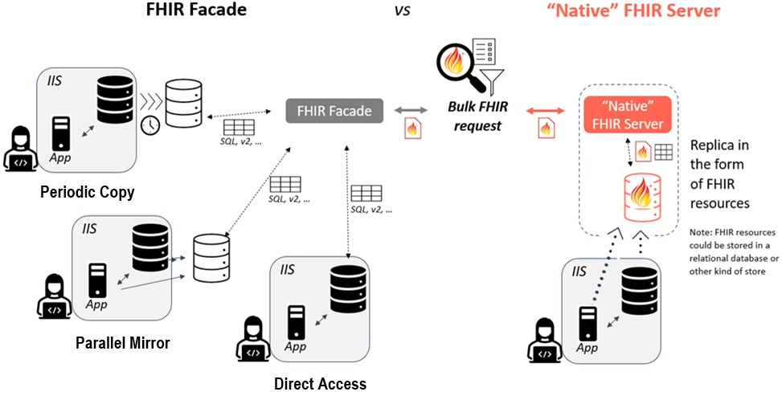

### 

### **Group Types**

A Group that is the subject of a Bulk Data query may fall into a few categories, depending on how the group is defined and the rate of change among its members. Generally, a group can consist of either an enumerated list of specific individuals for a population of interest or a description of the characteristics of the individuals that make up the population without explicitly listing them.

In the case of enumerated lists, individuals can be added to or removed from the Group as needed, ensuring that the list of relevant individuals is defined at any given time. Conversely, a characteristic-based Group would likely expand to a list of specific individuals only at the time of responding to the query. This "just-in-time" determination may impact query response time, as the responding system must first identify the appropriate individuals that meet the Group's characteristics before retrieving and making the data available. The optimal type of Group will depend heavily on the query's use case and the needs of the trading partners.

#### **Persistent Groups (enumerated)**

A persistent Group consists of a stable list of individuals, where the majority of members remain associated with the Group over time. While new individuals may be added or existing individuals removed, this type of Group is expected to be queried multiple times over an extended period. Example use cases include:

* A healthcare organization (HCO) creating a list of patients under long-term care.
* A payer maintaining a list of members for whom they are responsible.
* A research program tracking a defined list of individuals over time.

In the "Mechanisms for Patient Identification and Group Creation" section below, several approaches to creating and maintaining persistent Groups are described. While these approaches may allow for the removal of individuals, implementers should regularly review and maintain persistent Groups to ensure that the individuals included remain active and relevant. Without regular reviews, Groups may become bloated over time, negatively impacting system performance and efficiency by inflating data exchanges with unnecessary information.

#### **Transient Groups (enumerated)**

A transient Group consists of a list of individuals expected to change frequently or to be queried only once. In most cases, the Authorized User is the sole source of information about the Group's content, and the IIS may not have a way to identify individuals to add or remove independently. Example use cases include:

* An HCO creating a list of patients scheduled for appointments the following day, updating the list daily with new individuals.
* A school district generating a list of incoming kindergarten students and executing a bulk query before the start of the school year.

Use cases involving relatively small enumerated transient Groups may also benefit from the [Patient Operation](https://hl7.org/fhir/uv/bulkdata/OperationDefinition-patient-export.html), where the experimental patient input parameter specifies a list of Patient resources to include in the response as an alternative to using a Group.

#### **Characteristic Groups**

A characteristic Group consists of a set of qualities that describe the members of the Group. Individuals may be included or excluded based on these characteristics, with membership determined dynamically during the response to a query. For example, an Authorized User might create a Group that includes all individuals under a specified age with recorded immunizations residing in a specific zip code, allowing for data exploration without needing to create an enumerated list in advance.

While characteristic-based Groups may be useful for certain scenarios, this document will primarily focus on the use of enumerated Groups for the remainder of the discussion.

### **Maintaining Cohorts**

Once a Group has been established on the FHIR server for a particular use case serving an Authorized User, the next step is to establish an initial enumerated list of individuals belonging to the Group and to maintain its membership over time. While both Persistent and Transient Groups must be initially established, the maintenance of a Group is more relevant to Persistent Groups. As described in the Mechanisms for Patient Identification and Group Creation section of this document, there are multiple possible approaches to populating and maintaining a list of individuals in a Group. This section outlines general considerations for maintaining a cohort of individuals.

#### Considerations for maintaining a cohort

* **Group Size**: For use cases involving a persistent Group associated with a healthcare organization or payer, the number of individuals may be substantial. This can impact both the maintenance of the Group and the response times when querying the Group.
* **Patient Resource References**: The Group.member.entity field should reference a Patient resource contained on the IIS FHIR server, not a Patient resource defined on a different system (e.g., it should not reference a Patient resource on the FHIR client).
* **Data Persistence**: Depending on the technical architecture of the FHIR server implementation, the list of individuals in Group.member.entity may be stored in a manner consistent with the underlying IIS (e.g., in a relational database table or another mechanism).
* **Updates from Patient Resource Activities**: Activities affecting Patient resources in the IIS, which are independent of the Group's maintenance, may still require updates to the Group.
  + For example, if two patient records are merged in the data source and both original records are in the Group, the non-surviving record should be removed from the Group. If a new record is created for the merged individual, this new record should be added to the Group.
  + Conversely, if a single patient record incorrectly consolidates data from two separate individuals, the record may need to be "unmerged," resulting in two new patient records. This may necessitate removing the original record from the Group and adding one or both of the new records as appropriate.
* **Categorization Changes**: As individuals are categorized in the IIS, such as maintaining associations with external organizations like providers or schools, Group memberships may need to be updated.
* **Responsibility for Maintenance**: Depending on the use case served by the Group, either the Authorized User system or the IIS may need the capacity to add or remove patients from the Group.
  + In some cases, the IIS may take on this responsibility, particularly when it uses its own grouping logic to create persistent Groups for a specific Authorized User organization.
  + Alternatively, the Authorized User organization may be responsible, especially when using transient Groups where it is the only system that knows the Group's membership, such as when a healthcare organization queries for individuals with upcoming appointments or a school district queries for all students in a particular grade.
  + When onboarding an Authorized User, both trading partners must agree on which organization will bear primary responsibility for maintaining the Group.
* **New Operations in FHIR Release 5**: The FHIR Bulk Data Access Implementation Guide is based on [FHIR Release 4](http://hl7.org/fhir/R4). Beginning with [FHIR Release 5](http://hl7.org/fhir/R5), new [operations for managing large resources](https://hl7.org/implement/standards/fhir/operations-for-large-resources.html) are defined, including operations to add items to a Group (the [$add operation](https://hl7.org/implement/standards/fhir/resource-operation-add.html)) and remove items from a Group (the [$remove operation](https://hl7.org/implement/standards/fhir/resource-operation-remove.html)). These operations are similar to those developed by the [Da Vinci FHIR Accelerator](https://www.hl7.org/about/davinci/index.cfm) as part of their [Member Attribution (ATR) List Implementation Guide](https://hl7.org/fhir/us/davinci-atr/). While neither the R5 nor ATR operations may be directly supported by FHIR-based systems interested in Bulk FHIR, they provide valuable insights for implementing operations to maintain cohorts of individuals in a Group resource.

### **Data Payload**

The data payload returned in response to a Bulk Data query can vary. While this document does not specify the exact contents of a bulk query response for the immunization use case, it outlines the resource types that may be included in the response payload. Readers should refer to the Parameters section above for an introduction to the _type parameter, which specifies the response payload.

For queries to an Immunization Information System (IIS) for immunization-related data, expect at least two resource types: Patient and Immunization. These resources together describe the individual and a list of immunization events recorded by the IIS. Responses containing FHIR Patient and Immunization resources represent the immunization history for the set of individuals and may also include related resource types such as Practitioner, Location, Organization, RelatedPerson, ImmunizationRecommendation, and ImmunizationEvaluation to provide a comprehensive view of the patient’s history and context.

To align with existing implementation and regulatory requirements, it is highly recommended to adhere to US Core profiles when responding with data. The specific version of US Core selected may depend on trading partner needs and other FHIR implementations within the public health jurisdiction, but it is advisable to choose a version that complies with health IT regulations.

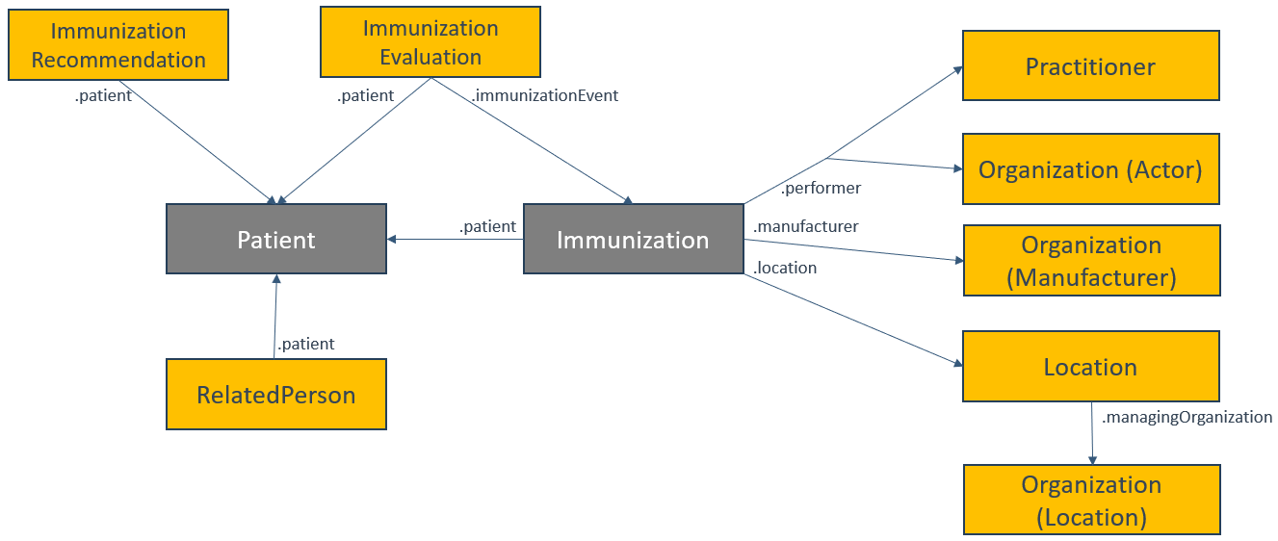

Data exchange partners must agree on the query response payload during the onboarding process to ensure that all data exchanges are appropriate for the involved parties.

## **Trading Partner Expectations**

The "Who is Involved" section outlines four key roles in the bulk exchange of immunization data: the jurisdictional immunization program, the Health Information Technology (HIT) vendor for the immunization information system (IIS vendor), the Authorized User organization, and the Authorized User HIT vendor. The term "IIS HIT Vendor" also includes jurisdictions that develop and manage their own IIS locally. Each role must implement essential technical and operational functionalities to support bulk data queries, regardless of the specific technology or approach chosen by trading partners. These functionalities relate to topics in the Policy Considerations and Technical Concepts sections, detailed below.

### **Foundational Technical Requirements**

The Authorized User HIT Vendor should expect to develop functionality to:

* Support mechanisms for large-scale patient matching.
* Create and/or update Groups.
* Generate Bulk Data Access queries to immunization programs.
* Retrieve and process data in response to Bulk Data Access queries.
* Make retrieved data accessible to end users and automated processes to support organizational objectives.

The IIS HIT Vendor should expect to develop functionality to:

* Support mechanisms for large-scale patient matching.
* Create and/or update Groups.
* Receive and respond to Bulk Data Access queries from Authorized User organizations.

### **Foundational Operational Requirements**

The immunization program should expect to develop processes and functionality to work with the Authorized User organization to:

* Identify and document use cases for Group creation and Bulk Data query
* Create and communicate the Group IDs relevant to a given Authorized User organization
* Select appropriate approaches to patient matching, cohort creation and data exchange
  + This may include the need to identify and implement any rules or requirements that must be met in order for a patient to be added to a Group used by a particular Authorized User organization.
    - Criteria may include certainty of matching (i.e., what is a high-confidence match), establishment of a relationship between patient and organization and others
    - This evaluation may apply to a variety of methods for updating a Group including V2 mediated exchange (i.e., does a V2 message imply a relationship with an organization), flat-file mediated exchange (i.e., are all patients in the file appropriate to add to a Group), FHIR-operations (i.e., are all Patients OK to add or remove from a Group) and more
* Identify and execute any required agreements with the Authorized User organization to exchange data on cohorts of individuals
* Implement IIS functionality required to support the agreed upon integration

The Authorized User organization should expect to develop processes and functionality to work with the immunization program to:

* Identify and document use cases for Group creation and Bulk Data query
* Select appropriate approaches to patient matching, cohort creation and data exchange
* Develop mechanisms to share Group IDs if the Authorized User organization is not permitted to directly create new Groups
* Identify and execute any required agreements with the immunization program to exchange data on cohorts of individuals
* Develop and implement processes and workflows necessary to:
  + Allow the selection of individuals for patient matching
  + Add identified individuals to a Group as appropriate
  + Remove individuals from a Group as appropriate
  + Deal with patient matching outcomes where a single high-confidence patient match is not found

## **Mechanisms for Patient Identification and Group Creation**

The Group Level Export operation outlined in the FHIR Bulk Data Access Implementation Guide assumes the presence of a Group resource on the FHIR server. This resource either contains a list of individuals within the Group or specifies criteria for identifying relevant individuals. However, the guide does not address how individuals are identified across systems or how Group resources are created and maintained. The Helios Bulk Data community has identified several approaches for patient identification and Group creation and maintenance. The following sections explore these approaches. During the onboarding process, trading partners should select one or more methods that align with their specific use cases.

### **V2-Mediated Matching (Automatic Group Creation)**

#### **Description**

Many trading partners, especially healthcare organizations, have established V2 messaging with one or more immunization information systems (IIS). Two common use cases for this exchange include immunization administration event notifications (using the VXU message type) and patient history/forecast queries (using the QBP and RSP message types). For detailed implementation guidance on V2-based immunization exchange, refer to the [CDC HL7 v2.5.1 Implementation Guide for Immunization Messaging, Release 1.5](https://www.cdc.gov/iis/technical-guidance/hl7.html).

V2 messaging inherently includes processes for exchanging patient demographic data, which can be utilized to match existing patients in the IIS. These processes can serve as a precursor to FHIR-mediated Bulk Data access. The exchange of one or more V2 messages for a specific patient between an Authorized User and the IIS may indicate a relationship between the individual and the Authorized User. Upon receipt of the V2 message, patient matching logic is executed, allowing the IIS to add the patient to a FHIR Group resource for use by the Authorized User in a Bulk FHIR query.

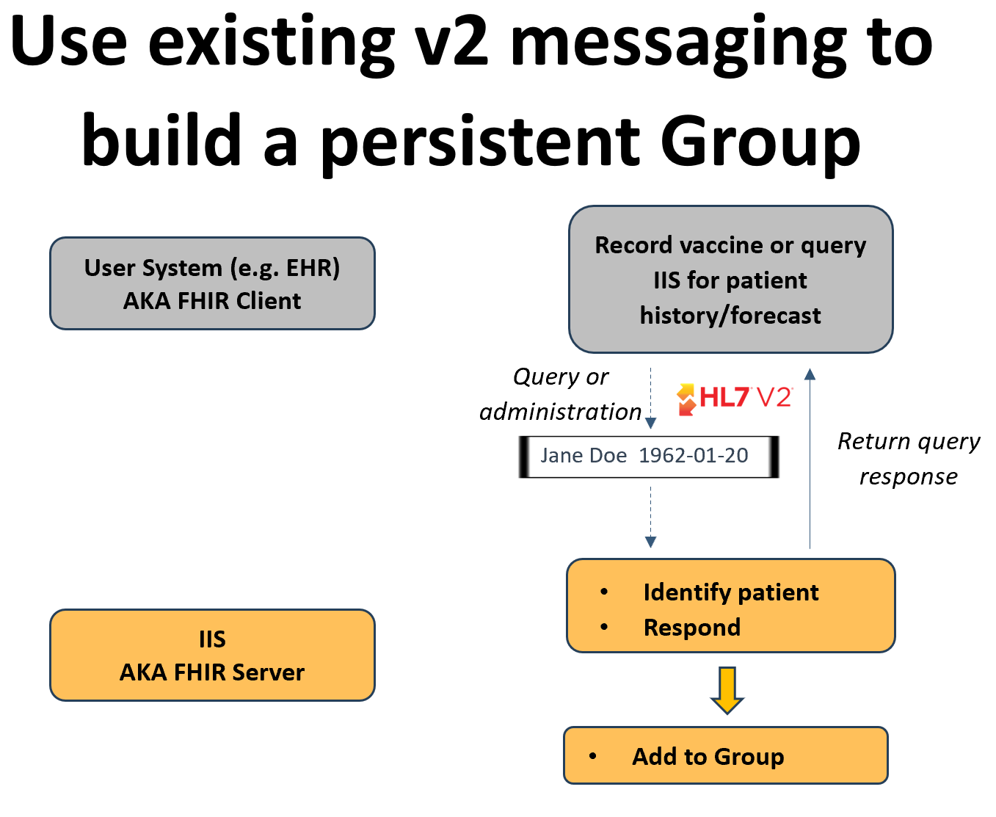

#### **Assumptions**

The use of V2 messaging to generate Groups for Bulk Data Access is an additional functionality beyond the standard actions performed by the IIS when processing V2 messages, such as data quality analysis, reporting, and creating groups for other purposes.

The FHIR Group resource, to which patients are added, is intended for use in Bulk FHIR queries representing the entire population of individuals associated with the Authorized User. Other groupings of individuals, whether using FHIR Group resources or alternative structures, may also exist for different purposes.

Typically, the Group ID will be shared with the Authorized User through out-of-band communication (e.g., during the onboarding process) and will not be included in any V2 response messages (ACK or RSP). Alternatively, the Group ID could be treated as a non-unique patient ID in an RSP response message and stored with the patient in the Authorized User's system to facilitate Group usage during the bulk query phase.

#### **Group Types Supported**

##### **Persistent Groups (enumerated)**

The creation of Groups through existing V2 messaging allows for the formation of a singular Group of enumerated individuals associated with the Authorized User. This association may arise from individuals receiving a vaccine from the Authorized User (resulting in a VXU message) or being queried by the Authorized User (resulting in a QBP message), in accordance with local jurisdictional policies. As new individuals are identified through V2 messages, they can be incrementally added to the Group, creating a persistent list of individuals known to the Authorized User. Note that some jurisdictions may not establish a patient-care association based solely on the receipt of a QBP message and may therefore not choose to add the individual to the Authorized User’s Group based on this V2 exchange.

#### **Benefits**

The V2-mediated approach minimizes implementation efforts for stakeholders by leveraging the established V2 messaging framework. Existing patient matching logic is utilized, eliminating the need for separate matching logic solely for bulk data access. Additionally, many IIS already establish relationships between individuals and Authorized Users based on V2 messaging. Consequently, many Authorized Users, particularly care-providing organizations, may already be exchanging V2 messages with the IIS, simplifying the onboarding process and testing.

#### **Limitations**

The V2-mediated approach is applicable only to organizations with an independent use case for V2 messaging with an IIS, making it impractical for certain Authorized Users, such as schools or community-based organizations.

This approach does not provide a direct method for removing individuals from an existing Group; it can only add individuals as V2 messages are processed. An exception may occur if local policy allows only a single association, necessitating the removal of an individual from an existing Group before adding them to a new one. This limitation may hinder an Authorized User's ability to receive data on all their patients if individuals receive services from multiple providers.

Due to these constraints, the V2-mediated approach is not well-suited for creating transient Groups, where the composition changes significantly over time and there is a need to dynamically add or remove individuals based on triggers other than V2 messages.

#### **Technical Requirements**

##### **IIS HIT Vendor**

In addition to supporting VXU and/or QBP/RSP V2 messaging, the IIS HIT vendor must implement functionality to assess the suitability of adding individuals identified during V2 message processing to a Group. Suitability criteria may include match certainty, the nature of the Authorized User, and local policies regarding the establishment of relationships between individuals and organizations.

##### **Authorized User HIT Vendor**

The Authorized User HIT vendor must support VXU and/or QBP/RSP V2 messaging with the IIS.

#### **Operational Requirements**

##### **Immunization Program**

The immunization program must facilitate the implementation of real-time V2 messaging with the Authorized User if it is not already operational. Additionally, it must develop and implement rules for determining the suitability of adding identified patients to a Group for the Authorized User.

##### **Authorized User**

The Authorized User must support the implementation of real-time V2 messaging with the immunization program if it is not already operational.

#### **Implementation Considerations**

When implementing V2 messaging for a new trading partner, the immunization program should inquire whether the Authorized User is interested in performing Bulk FHIR queries. The V2-mediated approach is not necessary for trading partners who do not intend to use Bulk FHIR queries. The immunization program should also check with existing trading partners regarding their interest in Bulk FHIR queries and implement this functionality as appropriate.

The criteria for adding individuals to specific Groups based on V2 message processing will be defined locally by the immunization program, including whether individuals may belong to multiple Groups simultaneously.

### **V2-Mediated Matching (Dynamic Group Creation)**

#### **Description**

The V2-mediated matching approach can also facilitate dynamic Group creation by the Authorized User through the use of existing V2 query messaging. Upon receipt of a V2 QBP message, patient matching logic is executed, and the FHIR Patient resource ID is returned in the RSP message as an additional patient identifier. The Authorized User's system can store this Patient resource ID alongside the corresponding patient record. Subsequently, the Authorized User can utilize the methodology outlined in the Maintaining Cohorts section of this document to dynamically create and update Groups by adding or removing individuals as needed.

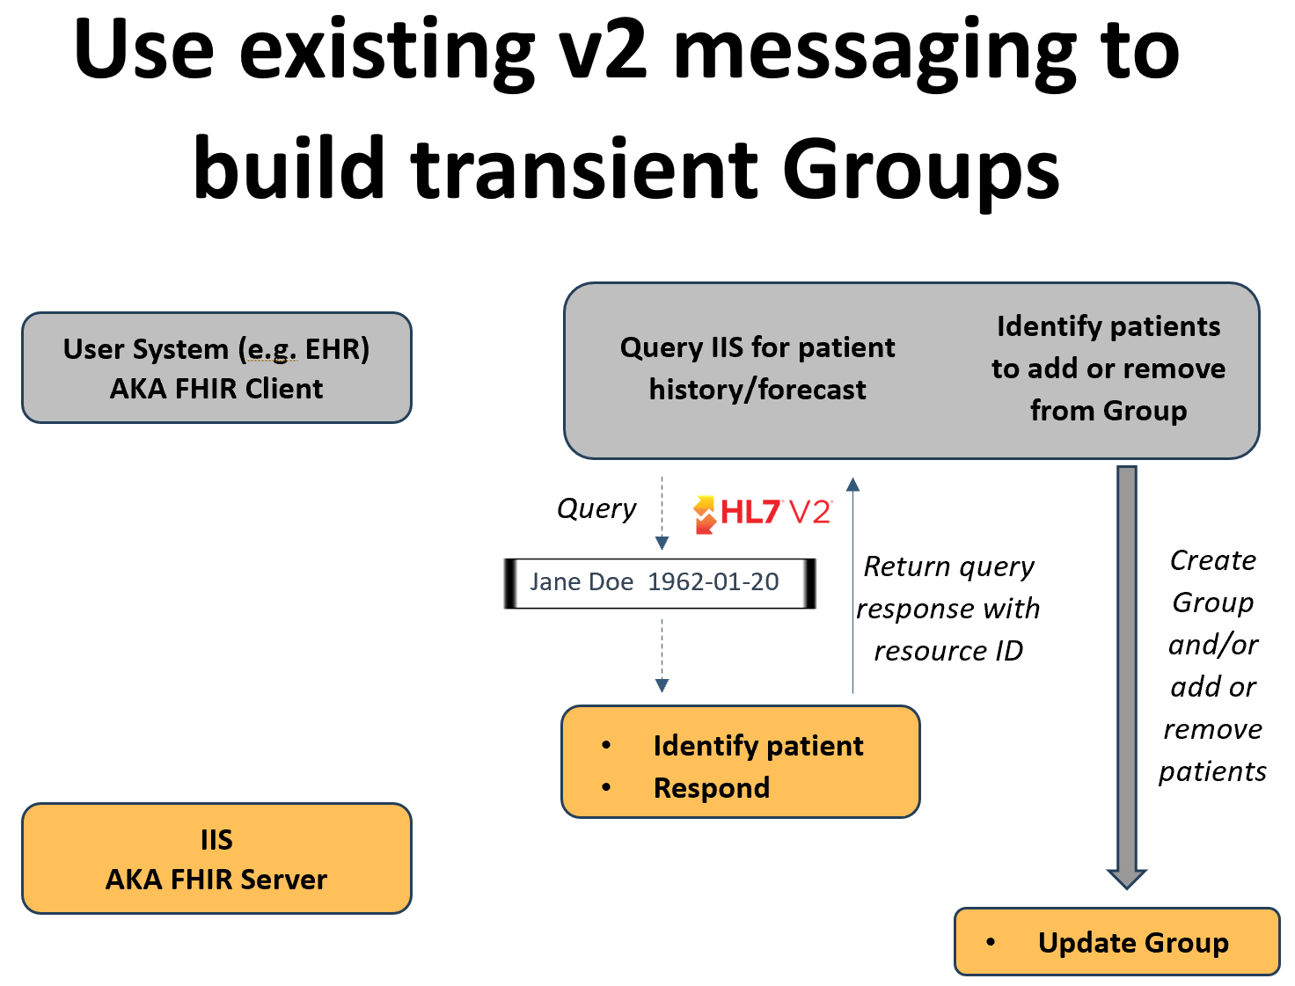

#### **Assumptions**

The use of V2 messaging to return the FHIR Patient resource ID for Bulk Data Access is an additional functionality beyond the standard actions performed by the IIS when processing V2 messages, such as data quality analysis, reporting, and creating groups for other purposes.

Since the Authorized User system may already have an existing FHIR Patient resource ID associated with an individual, it will validate that the returned ID from the V2 query response is consistent with previous patient matching outcomes. This includes ensuring that the returned ID is not associated with a different individual.

To maintain accuracy in the FHIR resource ID known by the Authorized User system at the time of the Bulk Data query, trading partners will agree on the duration for which a high-confidence patient match remains valid before a new match must be conducted.

The Group ID will be shared with the Authorized User through out-of-band communication and will not be included in the V2 query response message (RSP). Alternatively, the Group ID could be treated as a non-unique patient ID in the RSP response message and stored with the patient in the Authorized User system to facilitate Group usage during the bulk query phase.

The decision to add or remove individuals from the Group will originate with the Authorized User system, although the IIS may reject a request to add an individual if it determines there is no reasonable relationship between the individual and the Authorized User.

#### **Group Types Supported**

##### **Transient Groups (enumerated)**

The return of the FHIR Patient resource ID in the V2 query response enables the Authorized User system to dynamically create and update Groups, adding or removing patients as necessary to form transient Groups based on specific workflow requirements. For example, a transient Group of individuals with upcoming appointments can be created and queried.

##### **Persistent Groups (enumerated)**

The creation of Groups through existing V2 messaging allows for the formation of a singular Group of enumerated individuals associated with the Authorized Users. As new individuals are identified through V2 query messages, the Authorized User can incrementally add them to an existing Group, resulting in a persistent list of individuals selected by the Authorized User.

#### **Benefits**

The V2-mediated approach reduces implementation efforts by leveraging the established V2 messaging framework. It utilizes existing patient matching logic, eliminating the need for separate matching logic solely for bulk data access. Many Authorized Users, particularly care-providing organizations, may already be exchanging V2 messages with the IIS, simplifying the onboarding process and testing. Once the Authorized User obtains an individual’s FHIR Patient resource ID, they have the flexibility to update one or more Groups, allowing for the creation of both transient and persistent Groups.

#### **Limitations**

This approach is applicable only to organizations with a use case for V2 query messaging with an IIS, making it impractical for certain Authorized Users, such as schools or community-based organizations. Additionally, since the FHIR Patient resource ID must be returned, this approach is limited to V2-based query exchanges (QBP/RSP), as the standard acknowledgment for administration event messages (VXU) does not include a method for returning patient identifiers.

The stability of positive patient matches is uncertain. As patient demographics change, prior high-confidence matches may become outdated. This approach does not provide a mechanism for renewing patient matches without exchanging a new V2 QBP message.

#### **Technical Requirements**

##### **IIS HIT Vendor**

In addition to supporting QBP/RSP V2 messaging, the IIS HIT vendor should implement the ability to return the FHIR resource ID for a high-confidence match in the RSP response to a QBP query message. The IIS HIT vendor must also support the ability for Authorized User system directed Group creation (optional) and the dynamic addition and removal of individuals to the Group.

##### **Authorized User HIT Vendor**

The Authorized User HIT vendor must support QBP/RSP V2 messaging with the IIS as well as the ability to store the FHIR Patient resource ID in association with the patient record upon receipt of the RSP response message. The Authorized User HIT vendor must also support the ability to support Group creation (optional) and the dynamic addition and removal of individuals to the Group.

#### **Operational Requirements**

##### **Immunization Program**

The immunization program must support the implementation of real-time QBP/RSP V2 messaging with the Authorized User if not already live in Production.

##### **Authorized User**

The Authorized User must support the implementation of real-time QBP/RSP V2 messaging with the immunization program if not already live in Production. The Authorized User must also develop and implement workflows and processes to update Groups with individuals as needed.

#### **Implementation Considerations**

This approach should be implemented with a mutual understanding between trading partners that V2 QBP messages must only be triggered by the Authorized User system as part of standard clinical care activities. These messages should be used exclusively to obtain an individual's Patient FHIR resource ID. Utilizing V2 query messages for this purpose could place significant strain on the IIS query/response capacity.

When onboarding a new trading partner, the immunization program should determine whether the Authorized User is interested in performing Bulk FHIR queries. The V2-mediated approach does not need to be implemented for trading partners that do not plan to use Bulk FHIR queries. Additionally, the immunization program should check with existing trading partners regarding their interest in Bulk FHIR queries and implement this functionality as appropriate.

### **FHIR-Mediated Matching (Individual)**

#### **Description**

The FHIR base standard provides several methods for identifying an individual across systems. This includes searching for a [Patient resource](https://hl7.org/implement/standards/fhir/patient.html) and utilizing the [$match operation](https://hl7.org/implement/standards/fhir/patient-operation-match.html). Both methods incorporate the individual's demographics as known by the Authorized User system during the search process and can return zero, one, or multiple Patient resource IDs in the response. The Authorized User system can store the Patient resource ID in association with the corresponding patient record. Subsequently, the Authorized User can apply the methodology outlined in the Maintaining Cohorts section of this document to dynamically create and/or update Groups by adding and/or removing individuals as necessary.

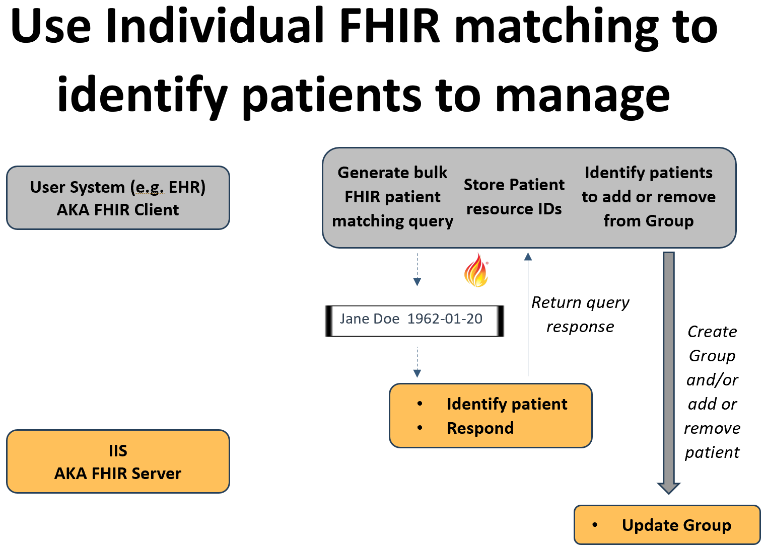

#### **Assumptions**

The outcome of patient matching in the IIS may result in 0, 1 or multiple individuals being returned as part of the response. Authorized User systems are expected to be able to handle all possible patient matching outcomes including a single high-confidence match, multiple high-confidence matches, multiple low-confidence matches, single low-confidence match and no matches.

The Authorized User system is permitted to validate the returned Patient resource matches the input data before associating the FHIR Patient resource ID with the patient record in their system.

In order to ensure that the FHIR resource ID known by the Authorized User system is accurate at the time of the Bulk Data query, trading partners will agree upon how long a high-confidence patient match is valid for before a new patient match must be conducted.

The Group ID will be shared with the Authorized User through out-of-band communication and will not be included in the query response. Alternatively, both systems must support the dynamic creation of Groups.

The decision to add or remove individuals from the Group will originate with the Authorized User system; however, the IIS retains the option to reject a request to add an individual if it determines that there is no reasonable relationship between the individual and the Authorized User.

#### **Group Types Supported**

##### **Transient Groups (enumerated)**

The return of the FHIR Patient resource ID in response to a Patient search or $match operation enables the Authorized User system to dynamically create and update Groups, adding or removing patients as necessary to form transient Groups based on specific workflow requirements. For example, a transient Group of individuals with upcoming appointments can be created and queried.

##### **Persistent Groups (enumerated)**

Identifying individuals through a Patient search or $match operation facilitates the creation of a singular Group of enumerated individuals associated with the Authorized Users. As new individuals are identified through these operations, they can be incrementally added to the Group, resulting in a persistent list of individuals known to the Authorized User.

#### **Benefits**

Most FHIR-enabled systems are likely familiar with the Patient search and possibly the $match operation, offering existing functionality that can be readily implemented.

Authorized Users have the flexibility to independently update one or more Groups, allowing for Group creation without imposing significant burdens on the immunization program.

#### **Limitations**

When dealing with large Groups, matching individuals one-by-one may require numerous interactions, potentially straining both systems.

The stability of positive patient matches is uncertain. As patient demographics change, prior high-confidence matches may become outdated. This approach does not provide a mechanism to validate or renew matches without performing a new search for the individual.

#### **Technical Requirements**

##### **IIS HIT Vendor**

The IIS HIT vendor must support the acceptance of data for individual matching, execute patient matching logic, and return any found matches in FHIR format. The vendor must also facilitate Authorized User system-directed Group creation (optional) and the dynamic addition and removal of individuals from the Group.

##### **Authorized User HIT Vendor**

The Authorized User HIT vendor must enable the system or an end user to identify individuals for addition to or removal from a Group prior to a Bulk FHIR query. The Authorized User system must be capable of initiating patient matching through either a Patient search or the $match operation, as well as validating and associating (if appropriate) a returned FHIR Patient resource ID with the individual’s record. The vendor must also support Group creation (optional) and the dynamic addition and removal of individuals from the Group.

#### **Operational Requirements**

##### **Immunization Program**

Specific operational requirements for an immunization program have not yet been identified.

##### **Authorized User**

The Authorized User must implement workflows that allow an end user or the system to identify individuals for matching and initiate that process. Additionally, the Authorized User must develop and implement workflows and processes to update Groups with individuals as needed.

#### **Implementation Considerations**

As Bulk FHIR Users are onboarded, it is essential to discuss the system impact of potentially conducting a significant number of individual queries. The nature and size of the Groups expected to be utilized will be critical factors in determining the feasibility of this approach for a given implementation.

### 

### **FHIR-Mediated Matching (Bulk)**

#### **Description**

The authors of the Bulk Data Access FHIR IG are exploring a [method to identify groups of individuals across systems](https://build.fhir.org/ig/HL7/bulk-data/branches/bulk-match/match.html). They propose an asynchronous $bulk-match operation, which is based on the standard [$match operation](https://hl7.org/implement/standards/fhir/patient-operation-match.html). The response will include sets of matching Patient resources. The Authorized User system can store the Patient resource IDs alongside the corresponding patient records. Subsequently, the Authorized User can utilize the methodology outlined in the Maintaining Cohorts section of this document to dynamically create and update Groups by adding or removing individuals as needed.

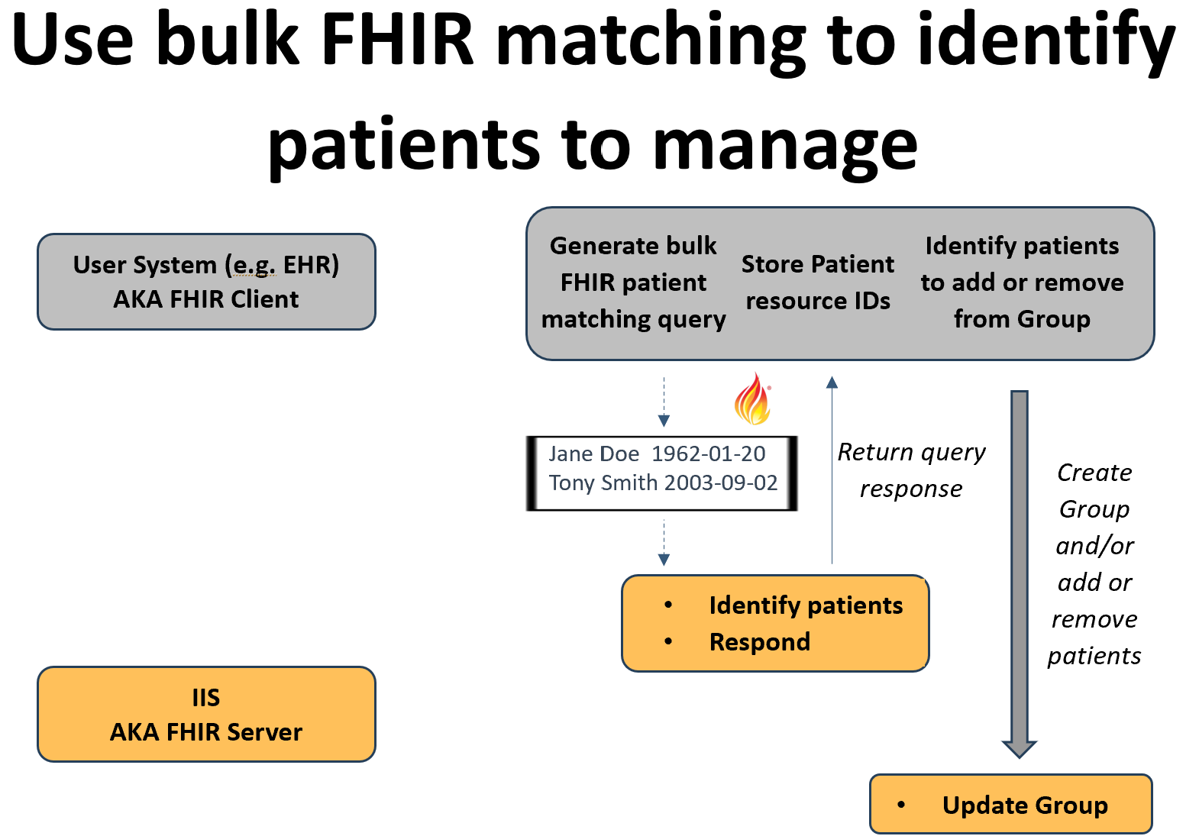

#### **Assumptions**

The outcome of patient matching in the IIS for any individual in the bulk matching request may yield zero, one, or multiple individuals in the response. Authorized User systems must be capable of handling all possible patient matching outcomes, including a single high-confidence match, multiple high-confidence matches, multiple low-confidence matches, a single low-confidence match, and no matches.

The Authorized User system is allowed to validate that the returned Patient resource for an individual matches the input data before associating the FHIR Patient resource ID with the patient record.

To ensure the accuracy of the FHIR resource ID known by the Authorized User system at the time of the Bulk Data query, trading partners will agree on the duration for which a high-confidence patient match remains valid before a new match must be conducted.

The Group ID will be shared with the user through out-of-band communication and will not be included in the query response. Alternatively, both systems must support the dynamic creation of Groups.

The decision to add or remove individuals from the Group will originate with the Authorized User system; however, the IIS retains the option to reject a request to add an individual if it determines there is no reasonable relationship between the individual and the Authorized User.

#### **Group Types Supported**

##### **Transient Groups (enumerated)**

The return of the FHIR Patient resource ID in response to the $bulk-match operation enables the Authorized User system to dynamically create and update Groups, adding or removing patients as necessary to form transient Groups based on specific workflow requirements. For example, a transient Group of individuals with upcoming appointments can be created and queried.

##### **Persistent Groups (enumerated)**

Identifying individuals through the $bulk-match operation facilitates the creation of a singular Group of enumerated individuals associated with the Authorized Users. As new individuals are identified through a FHIR bulk match, they can be incrementally added to the Group, resulting in a persistent list of individuals known to the Authorized User.

#### **Benefits**

The $bulk-match operation allows for the asynchronous matching of large numbers of individuals, minimizing the technical load on the IIS.

Authorized Users have the flexibility to independently update one or more Groups, enabling Group creation without imposing significant burdens on the immunization program.

#### **Limitations**

The $bulk-match operation is still under development and may not be widely supported.

The stability of positive patient matches is uncertain. As patient demographics change, prior high-confidence matches may become outdated. This approach does not provide a mechanism to validate or renew matches without performing a new search for the individual.

#### **Technical Requirements**

##### **IIS HIT Vendor**

The IIS HIT vendor must support the acceptance of data for a set of individuals to be matched, execute patient matching logic, and return any found matches in FHIR format. The vendor must also facilitate Authorized User system-directed Group creation (optional) and the dynamic addition and removal of individuals from the Group.

##### **Authorized User HIT Vendor**

The Authorized User HIT vendor must enable the system or an end user to identify a set of individuals for addition to or removal from a Group prior to a Bulk FHIR query. The Authorized User system must be capable of initiating bulk patient matching through the $bulk-match operation and validating and associating (if appropriate) a returned FHIR Patient resource ID with the individual’s record. The vendor must also support Group creation (optional) and the dynamic addition and removal of individuals from the Group.

#### **Operational Requirements**

##### **Immunization Program**

Specific operational requirements for an immunization program have not yet been identified.

##### **Authorized User**

The Authorized User must support the implementation of workflows to allow an end user or the system itself to identify a set of individuals to be matched and initiate that process. The Authorized User must also develop and implement workflows and processes to update Groups with individuals as needed.

#### **Implementation Considerations**

As Bulk FHIR Users are onboarded, the frequency of bulk patient matching requests should be discussed. Depending on the size of the set of individuals involved, the $bulk-match operation may be resource intensive, although the asynchronous nature of the operation may mitigate this concern somewhat.

### **Flat File Mediated Matching**

#### **Description**

Currently, the bulk exchange of immunization data frequently relies on flat file exchanges. A system generates a list of individuals, including the demographic data necessary for patient matching, and shares this file with the immunization program via SFTP or another method. The immunization program then uses the flat file to identify matching individuals and collect their immunization history data. This data is subsequently formatted into a flat file and returned to the Authorized User.

There are no established standards for generating either the input or output files, leading to custom file formats that create unnecessary work for both trading partners. However, since flat file processes are already supported by existing systems, using flat files to generate Groups for FHIR-based bulk data queries may serve as an appealing entry point for trading partners.

Purpose-developed flat files produced by the Authorized User system can be utilized to share patient demographics for multiple individuals. The IIS can ingest the file and execute patient matching, adding matched individuals to a Group resource for later querying. The criteria for adding a patient to a specific Group will be defined locally by the IIS in consultation with the Authorized User.

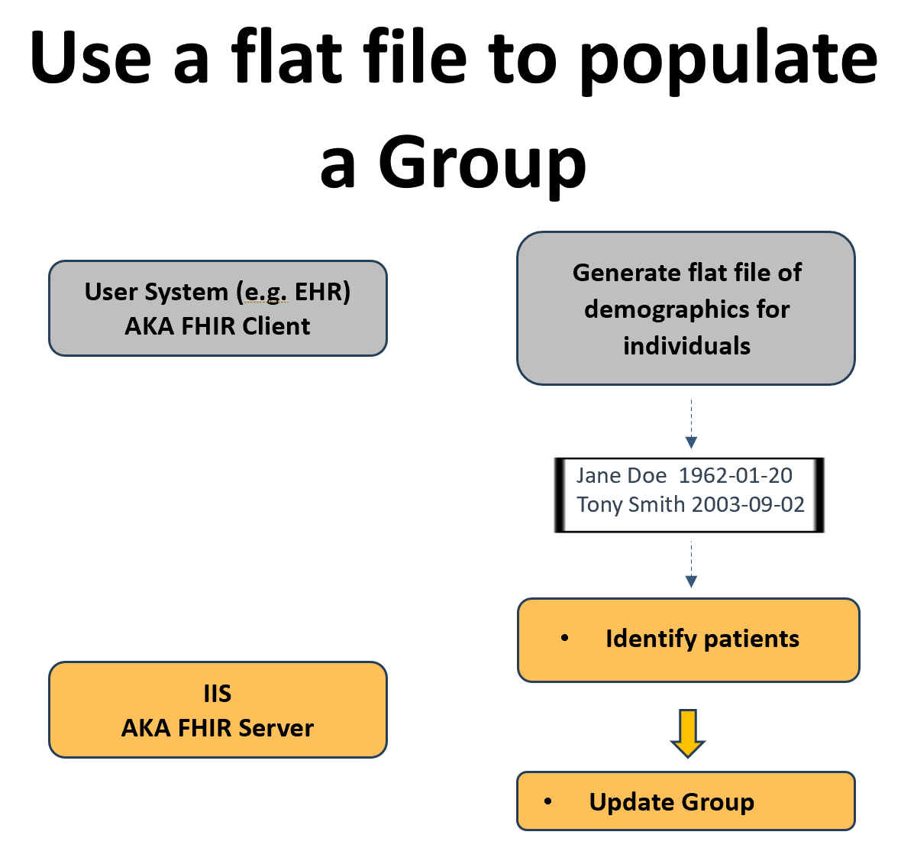

#### **Assumptions**

The Authorized User system can generate flat files according to agreed-upon specifications specifically for creating a FHIR Group for Bulk FHIR queries.

The FHIR Group resource is intended solely for use in Bulk FHIR queries. Other groupings of individuals, whether using FHIR Group resources or alternative structures, may also exist.

The Group ID will be shared with the Authorized User through out-of-band communication.

#### **Group Types Supported**

##### **Transient Groups (enumerated)**

The contents of the input flat file are at the discretion of the Authorized User; however, this flat file-mediated approach is best suited for transient groups of individuals. For example, a transient Group of individuals with upcoming appointments can be created and queried. The number of individuals included in the flat file and the frequency of submissions may vary.

##### **Persistent Groups (enumerated)**

Generating persistent Groups is possible, but trading partners must agree on the mechanisms for adding and removing individuals from the Group using flat files. When a new flat file is considered an addendum to the existing Group, new individuals submitted can be incrementally added to create a persistent list of individuals known to the Authorized User. However, removing existing individuals from the Group may be more challenging with the flat file approach.

#### **Benefits**

Trading partners with existing workflows that utilize flat files will be familiar with this process. For systems that currently support flat file exchanges, this approach minimizes the development effort required.

Authorized Users have the flexibility to generate flat files as needed, facilitating the creation of transient Groups.

#### **Limitations**

The exchange of a flat file is not supported by a standard FHIR workflow and must be negotiated locally.

Unless a standardized flat file format is agreed upon, IIS will have to adapt to the make up of the flat file provided by Authorized Users (or vice versa).

The use of flat files for patient matching represents only an incremental improvement on the current flat file mediated processes.

#### **Technical Requirements**

##### **IIS HIT Vendor**

The IIS HIT vendor must support the ability to receive and process a flat file containing demographics for multiple individuals and execute patient matching logic. They must also facilitate the addition of appropriate matches to a Group.

##### **Authorized User HIT Vendor**

The Authorized User HIT vendor must enable end users to generate a list of individuals for inclusion in a Group and create and transmit a flat file containing the relevant demographics in accordance with agreed-upon requirements.

#### **Operational Requirements**

##### **Immunization Program**

The immunization program must establish an agreed-upon process and format with the Authorized User for submitting flat files.

##### **Authorized User**

The Authorized User must develop an agreed-upon process and format with the immunization program for submitting flat files. Additionally, the Authorized User must implement a workflow that allows end users to create lists of individuals for inclusion in a Group.

#### **Implementation Considerations**

During implementation, trading partners must discuss the contents of the flat files and determine whether each new flat file should replace or append the contents of the existing Group.

If persistent Groups are desired, the mechanisms for removing individuals from an existing Group must also be addressed.

### **Reuse of Existing Groupings**

#### **Description**

An immunization program may have already implemented functionality within their IIS to create associations between individuals and organizations for purposes other than performing a Bulk FHIR query. For instance, an IIS might associate individuals with a provider or healthcare organization for quality reporting. These associations can be replicated within a FHIR Group, which can then be referenced in a Bulk FHIR query.

It is important to note that this approach does not require the IIS to alter the nature of the associations they are tracking or to use the existing sets of individuals for Bulk FHIR queries. Instead, it simply involves replicating the sets of individuals in FHIR Group format to make them accessible for bulk querying.

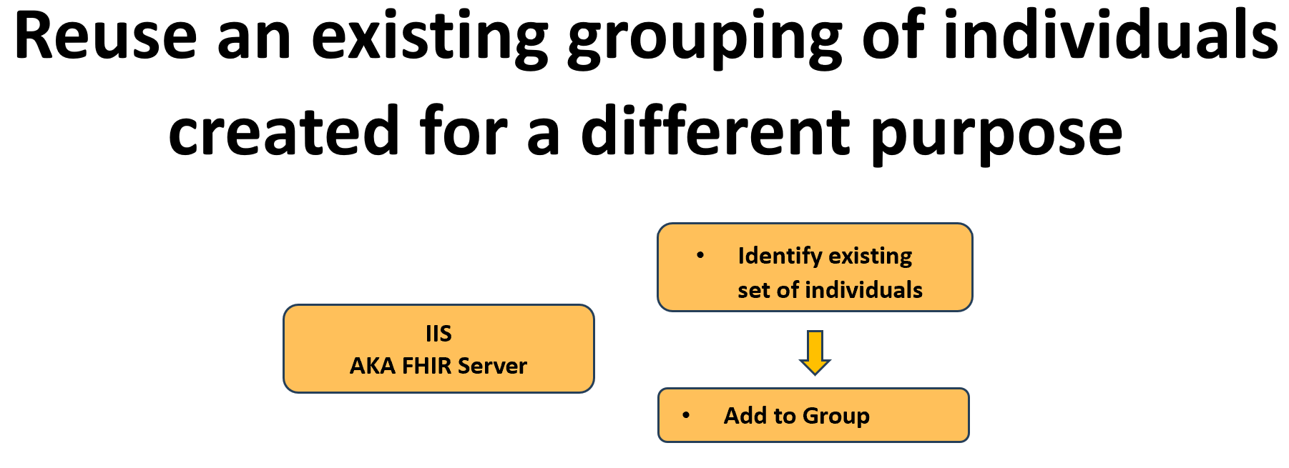

#### **Assumptions**

The requirements for creating the original associations should significantly overlap with the needs of the Bulk FHIR query.

The IIS may provide the capability to seed a Group based on existing associations while allowing the User to modify the Group through other mechanisms.

As associations are updated through these mechanisms, the IIS will actively maintain the Group as well.

The Group ID will be shared with the Authorized User through out-of-band communication.

#### **Group Types Supported**

##### **Persistent Groups (enumerated)**

Existing functionality to maintain cohorts of individuals in an IIS for functionality unrelated to bulk query is mostly likely to align best with persistent Groups that are maintained over time.

#### **Benefits**

Some IIS already maintain groups of individuals associated with external partners that may be suitable for use. Therefore, the logic necessary to establish these relationships should already exist, requiring minimal new development beyond replicating the associations in the form of a FHIR Group.

#### **Limitations**

Grouping logic may be implemented differently across various IIS, introducing variability for HIT vendors or Authorized Users operating across jurisdictions.

Existing grouping logic may not align well with the preferences of Authorized Users for performing queries. Specifically, the existing logic may not provide Authorized Users access to all individuals for whom they are responsible.

#### **Technical Requirements**

##### **IIS HIT Vendor**

The IIS HIT Vendor must support leveraging existing grouping functions to add individuals to a FHIR Group.

##### **Authorized User HIT Vendor**

Specific operational requirements for an Authorized User HIT vendor have not yet been identified.

#### **Operational Requirements**

##### **Immunization Program**

The immunization program must implement functionality to establish cohorts of individuals suitable for association with an Authorized User. Additionally, the immunization program must establish an understanding with the Authorized User to reuse existing grouping functionality for bulk query purposes.

##### **Authorized User**

The Authorized User must establish an understanding with an immunization program to reuse existing grouping functionality for bulk query purposes.

#### **Implementation Considerations**

When an Authorized User expresses interest in Bulk FHIR queries, existing associations should be reviewed to determine if they can serve as the basis for Group creation and maintenance.

### **Online Interface**

#### **Description**

An IIS may provide an online portal that includes an interface for Authorized Users to search for individuals and add them to a Group for subsequent queries. Additional functionality should be implemented to enable users to manage existing Groups, such as removing individuals from a Group or resetting the Group to remove all members.

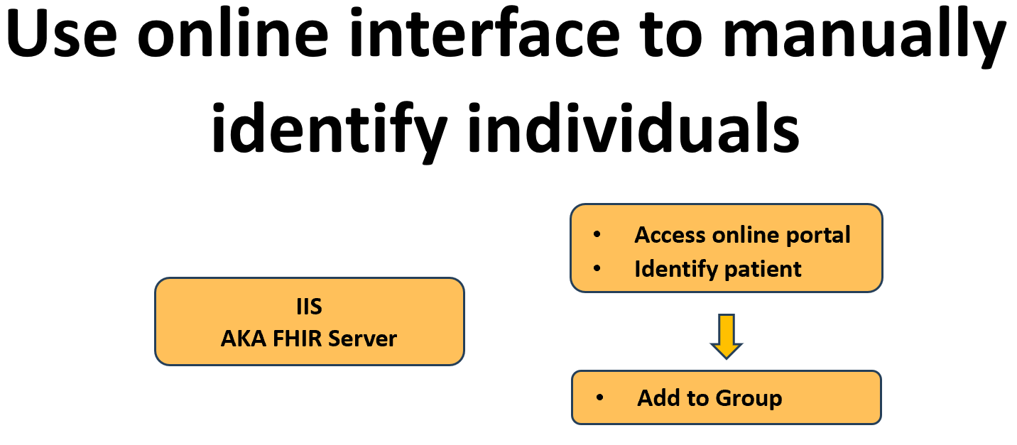

#### **Assumptions**

Authorized Users will manually enter sufficient demographic information to positively identify an individual.

The Authorized User system will implement a mechanism that allows an end user to manually trigger a bulk query once a Group has been updated through the online interface.

The Group ID will be shared with the Authorized User through out-of-band communication.

#### **Group Types Supported**

##### **Transient Groups (enumerated)**

When the size of a transient Group is manageable, an end user from the Authorized User may manually identify and add individuals to the Group. Given the nature of transient Groups, the need to remove an individual may be limited to correcting errors, but the ability to reset the Group to an empty state or create a new transient Group will likely be important.

##### **Persistent Groups (enumerated)**

Persistent Groups can be built over time by an end user from the Authorized User. The ability to dynamically add and remove individuals will be crucial for maintaining the Group over time.

#### **Benefits**

An online interface allows end users to create and maintain cohorts of individuals without requiring additional patient matching or Group manipulation functionality in the Authorized User system. It also ensures that a human can resolve multiple possible matches or low confidence matches.

End users may already be familiar with IIS functionality for finding and accessing patient records, which will ease the transition to creating Groups for bulk queries.

#### **Limitations**

For large cohorts, the effort required to identify individuals and manage Groups may be prohibitively high.

Manual entry of demographics by end users may lead to errors.

Using an online interface requires end users to leave the Authorized User system to identify individuals and create cohorts before returning to trigger the actual query.

#### **Technical Requirements**

##### **IIS HIT Vendor**

The IIS HIT Vendor must support the ability for end users to search for patients and add them to a Group through an online interface.

##### **Authorized User HIT Vendor**

The Authorized User HIT Vendor must support the ability for an end user to manually trigger a bulk query.

#### **Operational Requirements**

##### **Immunization Program**

The immunization program must implement an online portal for end user use.

##### **Authorized User**

The Authorized User must implement a workflow for end users to create Groups through the IIS online portal and then subsequently trigger the bulk query.

#### **Implementation Considerations**

This approach may have limited applicability unless the expected Group size is small, or the Authorized User is unable to implement one of the other approaches.

### **Subscription to Patient with Bulk**

#### **Description**

The [FHIR Subscription](https://www.hl7.org/fhir/subscription.html) paradigm provides an additional mechanism for creating Groups limited to individuals with known updates to their immunization data in the IIS. This approach relies on the IIS and Authorized User having shared the FHIR Patient resource ID, which can be accomplished through various methods described earlier in this document, including Bulk Patient Matching or V2 query/response.

Once the Authorized User possesses the Patient FHIR Resource ID, it subscribes to the individual via a Subscription Topic offered by the IIS. When the individual's record is updated in the IIS—potentially including changes to the Patient resource itself (such as demographic updates) or new, deleted, or updated immunization events—the IIS generates a notification bundle and sends it to the Authorized User.

The notification may consist of a comprehensive Bundle of resources, which could include Patient, Immunization, and ImmunizationRecommendation resources, allowing the Authorized User system to update without further data exchange. Alternatively, the notification may simply indicate which patient has been updated. The Authorized User can then add the updated Patient to a Group.

At a later time, the Authorized User initiates a Bulk Query, to which the IIS responds. Upon completion of the Bulk Query, the Group resource can be reset (removing all current patients) and reused as new notifications are received.

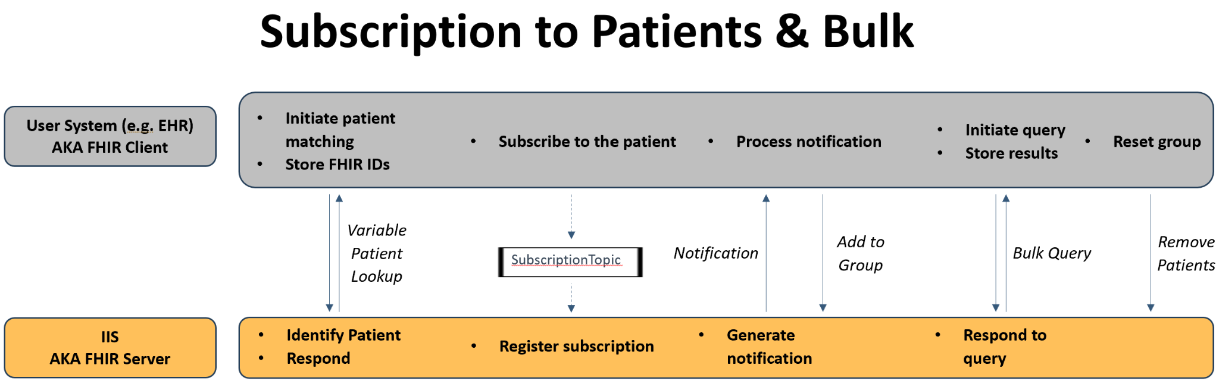

#### **Assumptions**

The implementation of either a Patient Subscription Topic or an Immunization.patient Subscription Topic will trigger notifications for patient-level changes (e.g., demographic updates) as well as changes to immunization events (e.g., doses reported, updated, or deleted).

When using a Bulk Query to retrieve data, the _since parameter may still be necessary (unless a complete patient snapshot is desired) to obtain only recently added data. The value of _since will likely correspond to the date of the last bulk retrieval.

The Group ID will be shared with the user through out-of-band communication and will not be included in any responses sent back to the Authorized User system.

#### **Group Types Supported**

##### **Transient Groups (enumerated)**

These Groups will be transient, meaning they will be reset periodically. This approach is designed to provide updates on stable patient populations rather than on individuals scheduled for upcoming visits.

#### **Benefits**

The Authorized User receives proactive notifications, potentially in real-time, when a patient of interest is updated.

At any given time, the list of individuals in the Group will consist only of those who have been recently updated (as indicated by recent notifications). This should reduce the overhead associated with queries by limiting the enumerated list of Patients to those known to have updated data.

#### **Limitations**

This approach does not address the underlying issue of positively identifying individuals across systems.

The introduction of FHIR subscription functionality requires support from both systems.

Authorized Users managing large cohorts of individuals may generate significant network traffic due to Subscription notifications.

#### **Technical Requirements**

##### **IIS HIT Vendor**

The IIS HIT Vendor must support a mechanism for individual identification. Additionally, the vendor must implement the basic FHIR subscription paradigm, including support for Patient and/or Immunization.subject level Subscription Topics, and accept subscription requests from the Authorized User.

##### **Authorized User HIT Vendor**

The Authorized User HIT Vendor must support a mechanism for individual identification. The vendor must also enable the ability to subscribe to updates for specific individuals and to receive and process notifications. Furthermore, the Authorized User HIT Vendor must implement functionality to add individuals to a Group and reset a Group by removing all existing Patients after a query is made.

#### **Operational Requirements**

##### **Immunization Program**

The immunization program must implement at least one mechanism for patient matching.

##### **Authorized User**

The Authorized User organization must implement at least one mechanism for patient matching as well as a workflow to trigger a Bulk Query (either scheduled or on demand).

#### **Implementation Considerations**

Trading partners must agree on a mechanism for patient identification and the sharing of FHIR resource IDs, as well as the nature and robustness of the notifications sent.

## **Mechanism for Bulk Query**

The mechanics of the FHIR Bulk Data Group Level Export are expected to be executed as outlined in the FHIR Bulk Data Access Implementation Guide. No further customization for the immunization use case is anticipated.

However, the Argonaut FHIR Accelerator, which sponsors the Implementation Guide (IG), is exploring enhancements to the standard. The three work streams under consideration include:

* Optimization of the _typeFilter parameter
* Organizing output files by Patient rather than by resource type
* Enhanced criteria-based group creation

For more details, please refer to the [Argonaut 2024 Bulk Optimize Project](https://confluence.hl7.org/display/AP/Bulk+Optimize) site.

## **Summary**

The work of the Helios Bulk Data Priority Area, outlined in this document, aims to provide a foundation for immunization programs and Authorized Users to implement this functionality. All interested organizations are invited to join the Helios Priority Area to collaborate on pilot testing and the eventual production exchange of immunization data. To suggest alternative use cases for other data sets, please contact the Leads of the Priority Area to schedule further discussions about your needs.

## 